**Problem Statement**

In this assignment students will build the random forest model after normalizing the variable to house pricing from boston data set. Following the code to get data into the environment:

**#importing libraries**

import numpy as np

import pandas as pd

import matplotlib.pyplot as plt

import seaborn as sns

from sklearn.model_selection

import train_test_split

from sklearn.preprocessing

import StandardScaler from sklearn

import datasets boston = datasets.load_boston()

features = pd.DataFrame(boston.data, columns=boston.feature_names)

targets = boston.target

print(features.shape)

features.head()

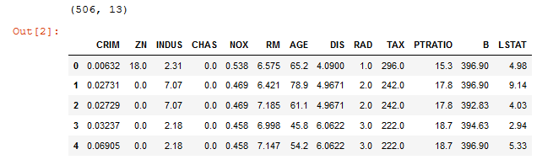

**# Now we have to standardize the data. We will use StandardScaler from preprocessing**

X_train, X_test, y_train, y_test = train_test_split(features, targets, train_size=0.8, random_state=43)

from sklearn import preprocessing

min_max_scaler = preprocessing.MinMaxScaler()

features_scaled = min_max_scaler.fit_transform(features)

features_scaled = pd.DataFrame(features_scaled)

targets = targets.reshape(506,1)

**# We can even check if we can reduce dimensionality of dataset using PCA, although here its only 13 features.**

%matplotlib inline

from sklearn.decomposition import PCA

pca=PCA()

pca.fit(X_train)

foo=pd.DataFrame(pca.transform(X_train))

x_axis=np.arange(1,pca.n_components_ + 1)

pca_scaled=PCA()

pca_scaled.fit(X_train_scaled)

foo_scaled=pd.DataFrame(pca.transform(X_train_scaled))

foo_scaled.hist()

plt.show()

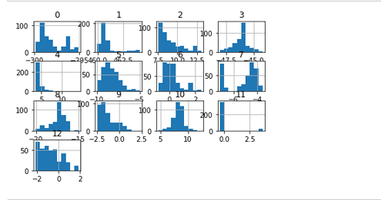

**# Import ,Instantiate,Fit**

from sklearn.ensemble import RandomForestRegressor

forest=RandomForestRegressor(n_estimators=1000,oob_score=True,random_state=18)

**# Oob_True :Whether To Use Out-Of-Bag Samples To Estimate**

**# The R^2 On Unseen Data.Is Kind Of Cross-Validation**

forest.fit(X_train,y_train)

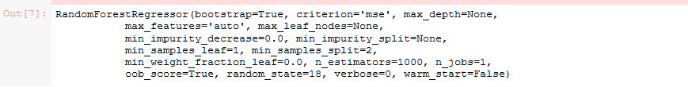

from sklearn.metrics import r2_score

preds=forest.predict(X_test)

test_score=r2_score(y_test,preds)

print(' R squared score:',test_score)

op4.PNG